Developing Projects with Geocaching

Andreas Klug

COMAPP – “Community Media Applications and Participation”
materials for download: http://www.comapp-online.de
This project has been funded with support from the European Commission.
This publication [communication] reflects the views only of the author, and the Commission cannot be held responsible for any use which may be made of the information contained therein.
PROJECT NUMBER: 517958-LLP-1-2011-1-DE-GRUNDTVIG-GMP AGREEMENT NUMBER: 2011 – 3978 / 001 - 001

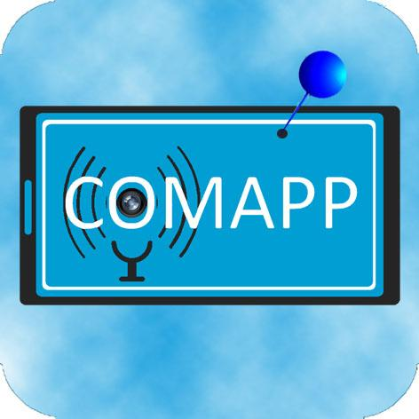

Contents

1. Contents 2
2. Geocaching: The Idea 3
3. Using a Platform 6
4. Equipment and Software 8
5. Preparations and the “Chase” 9
6. Designing your own Cache 11
7. Setting up your own Cache 13
8. Enhanced Functions 15
9. Literature/Links/Sources 16

Creative Commons:
Attribution-NonCommercial-ShareAlike

You are free to copy, distribute, and publicly transmit the content, and to adapt the work. Under the following conditions:
Attribution. You must attribute the work to the author/licensor.
Noncommercial. You may not use this work for commercial purposes.
Share Alike. If you alter, transform, or build upon this work, you may distribute the resulting work only under the same license as this one.
For any distribution, you must make clear to others the license terms of this work. Any of the above conditions can be waived by written permission of the copyright holder. The legal limitations of copyright are in no way affected by this license.

Geocaching: The Idea
GPS plus internet |  | Geocaching is often called a “modern scavenger hunt”. And it’s true that the point of geocaching is to find a certain location and whatever has been hidden there. But in comparison to the old-fashioned “paper chase”, there are two major innovations:  1. technical navigation aids are used  2. the hunt is organised via internet platforms.
Precursors |  | 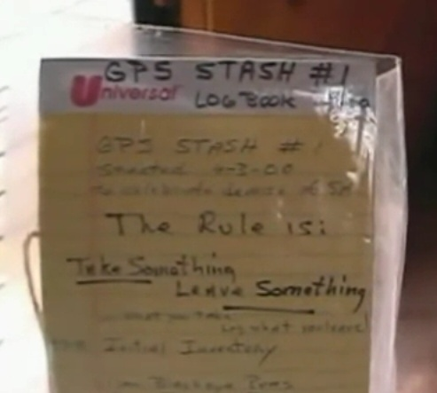  The basic idea (“Letterboxing”) can be traced back to the year 1854. A Briton living near Dartmoor in southern England hid a container and invited people taking walks to search for it and – should they find it – to deposit a message there. Letterboxing has remained a popular pasttime until today. Since the 1980s, particularly in Finland, search games have been pursued that involve such means of support as detailed maps and compasses. In May 2000, a more modern form originated when Dave Ulmer buried a “treasure” in Portland (Oregon/USA), recommending GPS-based navigation equipment for the search and reporting on its progress via Usenet, a precursor of today’s social networks. Thus, the two essential innovations were given, distinguishing this search from a traditional scavenger hunt.
The beginning |  | Since then, the search for Dave Ulmer’s black plastic pail (slogan: Get some stuff, leave some stuff) has developed into a globally networked game: on September 2, 2000, a list of caches was already posted at geocaching.com, and twelve years later, the two-millionth cache was listed there. The name is derived from the Greek γῆ, geo “earth”, and the English cache “secret storage place”; it’s pronounced 'dʒiːoʊ̯kæʃɪŋ. That is, ‘cache’ is spoken like ‘cash’ although it has nothing to do with money, and definitely not like ‘catch’ since it’s not a matter of capturing anything.
Variations |  | Today, there are various types of caches in practical use; the net community opencaching lists the following, among others:    Normal cache: the coordinates are posted, and the cache itself consists, e.g., of a tupperware dish with a logbook inside.    Multicache: the posted coordinates provide the starting point for a route leading, via several intermediate stations, to the cache. In order to reach the cache, at each intermediate point the coordinates of the next location have to be figured out – by solving a problem spelled out there.    Riddle cache: To locate a riddle cache (normal, multi, virtual), it is necessary to do research on location or on the internet.  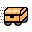  Moveable cache: In this case, the person who finds the cache hides it at a new location. The new coordinates are then posted via the internet community.    Virtual cache: There is no plastic container or logbook at the goal location. The search itself is the object of the game.  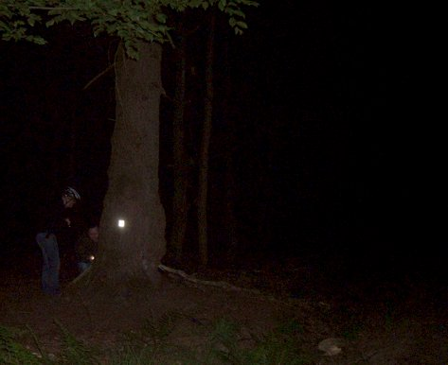    Night cache: A small reflecting object can be found only in the dark when searching – for example, in the woods – with a flashlight.
 |  | Of course, anyone can begin a search without being a member of a community or a “club”. But it is customary to leave behind a message when one has found a cache: either by the classical method of writing an entry in the logbook hidden there or replacing an object found there by another small object. In addition, there is the option of depositing a comment on the website where the cache was posted.
One special form involves geocaches that link the element of play to some additional content. For example, the cache “Partigiani” refers to historical events in the northern Italian province of Imperia by presenting itself as “A cache placed in memory of the Italian Partisans fighting the fascist regime”. A similar tribute would be the cache “Walter Benjamin” in Portbou, northern Spain. The cache “Galleria Chiusa – Bonus” connects content with sports challenges. And the multicache “Unterm Schönberg” offers insights into an interesting aspect of regional history in Freiburg, Germany.

In the comments, by the way, there is frequent mention of “muggles”: this is a reference, taken from the Harry Potter novels, to the “uninitiated” who may occasionally stumble upon a cache and think that it is garbage and should be thrown away ...

Using a Platform
The platform as a meeting point |  | Geocaching would actually be imaginable without any high-tech support, simply involving regular mail, maps, and compasses. On that basis, however, it surely would never have become a mass phenomenon. Internet platforms listing caches in a data bank play a significant role. What all these platforms have in common is the convenience they offer in searching – for a desired type of cache, for caches in a particular region or with a specified degree of difficulty. Information about the geocache one has selected can be downloaded from the platform and referred to while searching.
Commercial vs. “open” |  | Geocaching.com, founded in 2000 as the first platform of its kind, is maintained today by the company Groundspeak and provides by far the greatest number of caches, almost two million. Groundspeak also offers software for searching out-of-doors, on location. But among members of the “community”, the role of Groundspeak is a topic of debate: using the platform and the search software are both free of charge only up to a certain point; Groundspeak sells advertising space for fade-ins and even attempted (unsuccessfully) to register the term “geocache” as its own trademark.  Since the launch of opencaching.com in 2010, a second international platform has been available, maintained by the outdoor equipment manufacturer Garmin. One special feature here is the evaluation function allowing users to rate caches in detail.  But the only platform that is truly “open” is opencaching.eu with its portals for individual countries, such as opencaching.de, opencaching.es or opencaching.pl. Their respective data banks are maintained by the geocaching community itself and are always available for use free of cost, without restrictions, and without a personal registration. In the chapter on “Setting up your own cache” we will take reference to opencaching.eu.
Selecting a cache |  | Working at the home computer, one can select a suitable cache from one of the abovementioned platforms, for example by narrowing down the search results according to criteria such as distance from one’s own location, postal code, or place name.  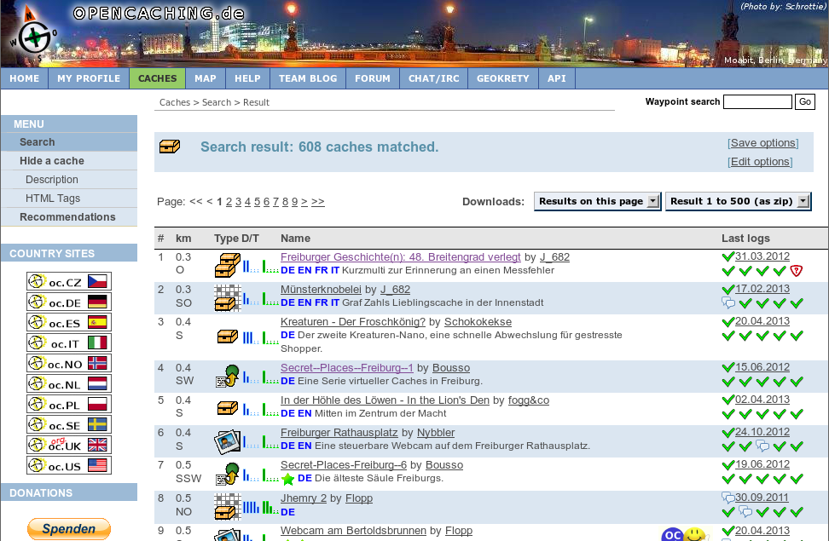  Since both the search functions and the descriptions of caches are self-explanatory, no further instructions are necessary here. But it is essential to download the desired geocache files (preferably with the suffix gpx) onto a smartphone. These gpx files contain all the information one needs for searching on location.
 |  | Alternatively, it’s also possible to select a cache directly on a smartphone that has internet access. Since the device is equipped with a GPS-based geolocation function, it’s very convenient to look for “caches in my vicinity” and to download the gpx files directly onto the smartphone. More about this in the next chapter.

Equipment and Software
Outdoor or universal device |  | The devices generally used for hunting a cache are either outdoor navigation devices or conventional smartphones. Both types of device determine their own position by communicating with a satellite-based GPS system. In the cache data downloaded from a geocaching platform in the form of a gpx file, there is additional information contained about the locality and for the search, and this information can be utilized by the mobile device. Outdoor navigation devices have the advantage of being rugged and having longer battery life. Smartphones, on the other hand, are multifunctional devices that may already be available. In addition, they always offer the option of making connection with the internet to fetch additional cache files or download other relevant information.
In most cases, geocaching is an interface of three components:
1. The geocaching data bank: for the reasons given above, here we will access platforms that can be reached via opencaching.eu.
2. Compact hardware: we will assume that an Android smartphone is in use; decent models are available for under 100 €. It’s not even necessary to have mobile phone service, since the essential gpx file can be downloaded via a home internet connection and transferred to the mobile device. In general, any smartphone can be used for geocaching.
3. Suitable software: an application or “app”.
Apps |  | The greatest range of geocaching apps, by far, is available for Android. “c:geo” is in wide use. The app “Columbus”, which will be illustrated in the next chapter, supports contact with the popular data banks (including opencaching.eu …), and it can depict maps generated in the OpenStreetMap project, which especially in remote hiking areas are clearly superior to Google maps. Columbus is free and offers a users guide in a number of languages.  The official Groundspeak app “Geocaching” is available for Android, iOS and WindowsPhone, but one has to pay for it, and it can only be used in conjunction with the platform geocaching.com. Other apps such as CacheDroid or OpenCaching (Garmin) or GeoBeagle are not highly recommendable. Some can only access certain portals, don’t display maps precisely enough, or are simply clumsy to handle.

Preparations and the “Chase”
The app Columbus |  | The role played in a classical scavenger hunt by hand-drawn maps, scraps of paper, or trails of sawdust in the woods is taken over by the gpx files in geocaching. These contain all the information that a mobile device needs to lead the user to the area where the stash is to be found. As already explained, these files are downloaded and then used during the search.  The Columbus opening screen displays the list of geocaching files that have already been stored on the device, if any. The opening screen can always be accessed via the left button in the row of five main buttons (at top of screen). There are two ways to add files to the list:
Selecting a cache |  |   With the Columbus opening screen visible, use the menu key of the smartphone to enter search mode. Pressing “nearest online” initiates the search for cache files in the vicinity of your current location. The button “cache site” (which is a bit hard to find) allows you to choose what platform(s) should be searched. To do this, you must have internet and GPS access. If you are using an open platform, such as opencaching.de, the gpx files can now be downloaded immediately; on commercial platforms (like geocaching.com) you need an existing account that has already been specified in the Columbus settings.

The other option is to transfer the files manually from a computer onto which they have been downloaded. In order to utilize the import function fully, you should pre-install the Android app “OI File Manager”. When using this method, it is not necessary that the smartphone have internet or GPS access.
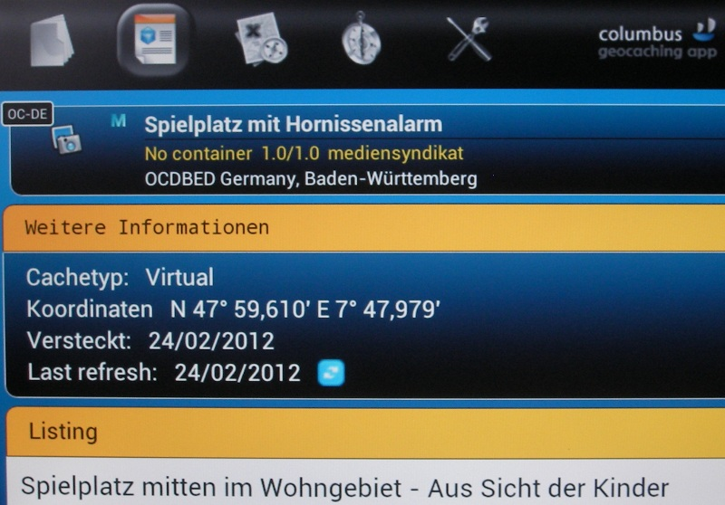
The cache file you have loaded now appears in the list on the opening screen, so that it can be selected and viewed. Often, the texts contain important information about searching for the cache. Occasionally, external links are also embedded in the text. In such cases, you can access more extensive texts, images, sounds, and even videos.
Two displays: |  | Via the main buttons (at top of screen) you can choose different displays. For practical purposes while searching out-of-doors, there are two useful options:
1. Map mode |  |   The map mode indicates where the user is currently situated. It may be necessary to activate this via the menu button of the smartphone (“My position”). The location of the cache is also visible. You may need to adjust the zoom factor on the map to your momentary needs. As a matter of course, the cache search is subject to the GPS standard deviation of a few meters. This means that the actual treasure has to be searched for and found analogously, for real!  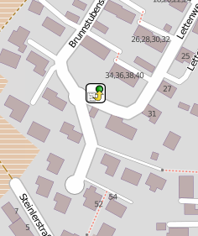  The map material you use depends on your personal preference. But particularly when the location is farther away from centres or large cities, it is recommended to have a look at the OpenStreetMap (OSM) material, which is very true to detail. You make your selection by using the menu button in map mode.  While outside on your search, it is not absolutely necessary to have internet access: if you have downloaded the map segment in advance using your home WLAN, it will later be available offline during your search.
2. Compass and direction function |  | 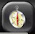  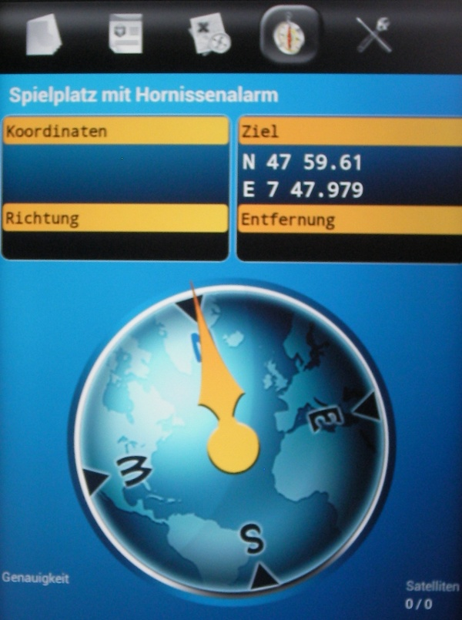  Alternatively, the search can be pursued using the compass and direction function. You see your own current position and the geographical coordinates of the goal. In addition, the compass gives you a distance estimate in meters of how close you may already be to the stash.  In both cases, it is possible at any time to switch your display back to the list or detail view in order to get support or additional information.

Designing your own Cache
Preparation |  | Before setting up one’s own cache, it is wise to make some preparations. You’ll need to decide on the type of cache (see Chapter 2) and to give it a name that speaks for itself. You should write a short description as well as a text that is a bit longer, particularly if there is some interesting content relating to the cache. It’s also nice to have a photo (one that you’ve taken yourself – for copyright reasons!).
Geocoordinates |  | Absolutely essential to geocaching are the geocoordinates. It’s important to know that there are several different ways of naming geographical coordinates. Google and other maps use a different notation system, for example, than the one generally employed in the geocaching community. But it is not difficult to convert coordinates from one system to another; the necessary tools are available on the net. Here are the three notation systems, applied to the latitude and longitude of the University of Education in Freiburg, Germany:
Unit | Notation
Decimal degrees | 47.98079 7.89378 | Here, the decimal system is used.
Degrees° minutes' seconds" | N47° 58' 50.844" E7° 53' 37.608" | The notation of minutes and seconds is based on a count of 60, and the listing for seconds is followed, after a decimal point, by a decimal value.
Degrees° decimal minutes | N47° 58.8474 E7° 53.6268 | This notation commonly used in geocaching gives the latitude and longitude in degrees and a value in minutes followed by a decimal point and a decimal value.

The scientific basis for these notation systems, which can define any point on earth univocally, is the World Geodetic System 1984 (WGS 84), a standard reference system for designating positions on the earth and in near-earth outer space. Whenever decimal system numbers are used, they are separated by a decimal point.

For conversion of the various notation systems, there are a number of convenient tools available on the web. Some examples:
http://boulter.com/gps/
http://rechneronline.de/geo-koordinaten/
http://www.koordinaten.de/online/koordinaten_umrechnung.shtml

Setting up your own Cache
opencaching.eu |  |   In Chapter 3, it was explained that there are various platforms where geocaches can be found. In the following, we will refer to the open platforms accessible via opencaching.eu. At this address, you can choose the portal for the country in question.
Registration |  | The advantage of open platforms is that they can be used free of cost at any time; but in order to set up caches of your own, you do have to register initially. The data protection stipulations are clearly formulated in the interest of the user, and in the experience of the author there is no cause for concern about the requirement that you give your own e-mail address. On the contrary, it provides the additional advantage of being able to request mail notices, for example concerning the maintenance of one’s own cache.
Creating a new cache |  | 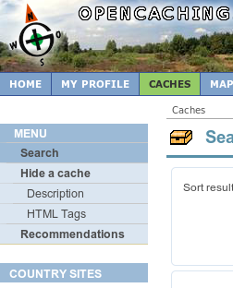  In the upper navigation bar, select the item “Caches” and then in the main menu at the left the item “Hide a cache”. Under this heading you will find several boxes to be filled in with information about your own cache. Most of the boxes are self-explanatory, particularly after a look at the “description” offered at the top. Just try out the various input boxes.
How do I find out the coordinates for my cache? |  | To obtain the correct geocoordinates for your hiding place, there are two methods. Either you take your smartphone to the site and then make note of the latitude and longitude that your device establishes via GPS. Or you use OpenStreetMap on your home PC: With the zoom set at the highest possible resolution, move the mouse pointer to the location of your cache. The map openlinkmap.org, is particularly convenient for doing this, it displays the geocoordinates of your mouse pointer directly below at the right. For conversion of the geocoordinates, the previous chapter provides the necessary background. Please don’t forget to separate decimal digits with a decimal point (rather than a comma).
Explanation of the cache |  | To make your cache more attractive for potential users, you should assign the cache attributes as requested and also write a description that will make people curious. Needless to say, you can also link in an image, or even multimedia. More about this in the following chapter.
Save draft |  | Especially when setting up a cache for the first time, it is advisable to wait before publishing it: in the section “other settings”, choose the item “do not publish yet”. This allows you to try out the cache on location and make corrections before publication if necessary.  With the button “send cache”, the entries are transferred to the platform server and stored there. They can be reloaded and edited at any time.
Trying out the geocache |  | As described in Chapter 3, the cache you have set up can now be downloaded as a gpx file and tested on location with your mobile device. To do this, on the opencaching page select the item “My profile” in the upper navigation bar. Under the heading “hidden caches” you will find your cache (which has not yet been published). As you see: although you have only saved your cache as a draft, you can nonetheless download it in gpx format with the button “download as …”, then transfer it to your smartphone and use as described in Chapter 5.
Publishing the cache |  | If you are satisfied with your test of your own geocache, you should publish it. On the page where your cache is listed, select the “edit” button. In the template that you are already familiar with from the previous work steps, down in the section “other settings”, you can now release your cache for publication.

Enhanced Functions

Multimedia cache |  | An option that is not yet in general use is that of enhancing the search with multimedia. Technically, it is not difficult to do. Mark a word in your descriptive text, and click on the chain symbol in the input box of the cache description. A small window will open, and here you can enter the link to an audio or video file in the “address” box. Important: the file that you name has to be accessible on the internet.  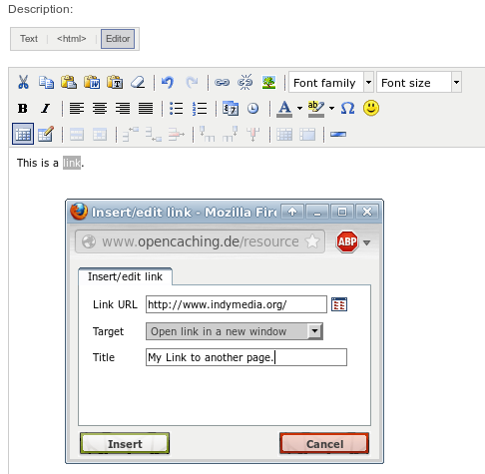  Be sure to use formats/codecs that are widely distributed, e.g. for audio mp3 or for video mp4.

Literature/Links/Sources

Basic information |  | http://www.cachewiki.de/wiki/Hauptseite
Overview smartphones |  | http://www.heise.de/mobil/handygalerie/
Sources |  | The image on page 4 is being used under the License CC-SA from Zeitan/wikimedia.org  The graphics on pages 7, 14 and 16 are from the webpage opencaching.de (Licensing Conditions)  The screenshots on pages 9 and 10 are from the Open Source Software Columbus

